Air Quality Monitoring Using IoT Sensors

Shubham Raj
Apex Institute of Technology CSE
Chandigarh University)
Mohali, India
24BDA70090@cuchd.in
Aryan Raj
Apex Institute of Technology CSE
Chandigarh University
Mohali, India
24BDA70100@cuchd.in
Vicky Kumar
Apex Institute of Technology CSE
Chandigarh University
Mohali, India
24BDA70087@cuchd.in
Raghuvir Kumar
Apex Institute of Technology CSE
Chandigarh University
Mohali, India
24BDA70011@cuchd.in

Pavandeep Kaur
Apex Institute of Technology, CSE
Chandigarh University
Mohali, India
pavandeep.e15947@cumail.in

Abstract— Air pollution is a major global concern that harms human health, ecosystems, and climate balance. Reports show that more than 90% of the world’s population is exposed to unsafe air, leading to millions of premature deaths each year. Traditional monitoring stations, though accurate, are expensive and cover only limited areas. To address this gap, this work proposes an Internet of Things (IoT)-based air quality monitoring system using low-cost sensors, ESP32 microcontrollers, and cloud platforms. The system measures pollutants, humidity, and temperature in real time and provides alerts when pollution levels exceed safety limits. The system's effectiveness is demonstrated through a real-world "Bad Air" alert, generated automatically by the cloud platform and delivered via a mobile notification. Compared with traditional setups, this solution is scalable, affordable, and community-friendly, making it suitable for smart city applications.

Keywords— Air Pollution, IoT, ESP32, Air Quality Index (AQI), Real-time Monitoring, Cloud Integration

Introduction
Air pollution has emerged as one of the most critical environmental challenges of the 21st century. It is largely caused by rapid industrialization, urban expansion, deforestation, the burning of fossil fuels, and the increasing number of vehicles on roads [1]. The World Health Organization (WHO) has estimated that over 7 million premature deaths occur annually due to exposure to polluted air, making it a global public health emergency [2]. Pollutants such as particulate matter (PM2.5 and PM10), carbon monoxide (CO), sulfur dioxide (SO₂), nitrogen oxides (NOx), and volatile organic compounds (VOCs) contribute not only to respiratory and cardiovascular diseases but also to neurological disorders and reduced life expectancy [3].
Beyond human health, air pollution has a direct impact on the environment. It accelerates climate change by increasing greenhouse gases, leads to the formation of acid rain, reduces visibility, and causes harm to agricultural productivity and biodiversity [4]. For example, rising levels of ground-level ozone are damaging crops and natural vegetation, which poses a threat to food security. Therefore, monitoring air quality is essential not just for immediate health protection but also for long-term sustainable development. Traditional air quality monitoring systems are typically based on fixed, government-operated stations equipped with high-precision instruments. While these provide highly accurate readings, they are expensive to install and maintain [4]. As a result, only a limited number of stations are deployed in most cities. For example, a large metropolitan area may have only a handful of monitoring sites, leaving many neighborhoods without localized data [9]. This creates a gap where citizens remain unaware of the true pollution levels in their immediate surroundings. The rapid growth of the Internet of Things (IoT) offers a new solution to this problem. IoT refers to the integration of smart sensors, microcontrollers, and communication networks to collect, process, and transmit data in real time [5]. In air quality monitoring, IoT allows the deployment of low-cost sensor nodes that can be distributed widely across a city. These nodes provide hyper-localized data, making it possible to monitor pollution variations street by street [6,7].
Researchers have already demonstrated IoT applications in smart homes, agriculture, healthcare, and transportation. Extending its use to environmental monitoring has shown promising results [10]. By leveraging microcontrollers like ESP32, sensors such as MQ135, and cloud APIs such as ThingSpeak and Firebase, it becomes possible to build a real-time, community-centered monitoring system that is both affordable and efficient.
This study proposes and evaluates an IoT-enabled air quality monitoring system designed to track pollutants, temperature, and humidity. The system processes data locally on the ESP32 using C++, transmits results securely to cloud servers, and provides real-time alerts when pollutant levels exceed safe thresholds. Unlike traditional monitoring stations, the proposed system is affordable, scalable, and accessible, thereby promoting community awareness and supporting the vision of smart and sustainable cities.

Literature Review

Review of Prerequisite Skills
- IoT Devices: Studies highlight that IoT devices such as ESP32 and Raspberry Pi are widely adopted in air quality projects due to their affordability, open-source support, and compatibility with sensors like MQ135 (gases) [5, 7, 9].
- Sensor Data: Literature emphasizes the importance of sensor calibration. While sensors provide low-cost monitoring, cross-validation with government data ensures accuracy. Recent works use machine learning to correct sensor drift [16, 17, 19]. Real-Time Monitoring: Real-time monitoring has proven effective in smart city projects, where immediate insights are crucial for traffic regulation, healthcare warnings, and urban planning [10].
- APIs: Many projects integrate ThingSpeak, OpenWeatherMap, Google Cloud, and Firebase APIs to visualize and store air quality data. APIs also allow comparison with official air quality indices [5, 10, 15].

Research Gap

While research in IoT-based monitoring is progressing, several gaps persist:

- Edge-level Processing: Many prior projects used remote processing (server-side). Fewer systems exploit ESP32’s on-device processing to do initial cleaning and health-checks (reduces bandwidth/cost) [5].
- Firmware Standardization: Diverse firmware implementations make large-scale fleet management harder. A standard C++/ESP-IDF approach simplifies OTA updates and maintenance [15].
- Secure Transmission: Some low-cost systems post plaintext HTTP; best practice is TLS (HTTPS/MQTT over TLS) — more ESP32 examples in C++ are needed [7], [10], [16].
- Sensor Lifespan & Calibration Strategy: Deployment-level strategies for recalibration and drift compensation (scheduled recalibration using reference station cross-checks or ensemble correction) are still underdeveloped [17], [19].

This paper addresses these gaps by providing an ESP32+ C++ firmware architecture that includes local cleaning, thresholding, secure uploads, and a multi-channel alert approach.

TABLE 2: Summary Of Literature Review In Tabular Form

Ref | Year | Study Title | Approach/Method | Tools/Tech Used | Key Indicators | Major Findings
[5] Varma et al. | 2017 | IoT-based Gas Leakage & Smart Alerts | Integrated IoT system for early warning | Arduino Uno, GSM, ThingSpeak | Gas threshold (LEL), temperature, humidity | System triggers buzzer & cloud alerts once gas crosses the limit
[6] Evalina & Azis | 2020 | Gas Monitoring with ATMega8 | Microcontroller-based LPG detection | ATMega8, MQ-6 sensor, LCD, buzzer | Early detection of leakage | Leakage displayed on the LCD & alarm raised
[7] Shobha et al. | 2021 | Hazardous Gas Monitoring via IoT | Feedback-based classification system | Arduino UNO, MQ2 sensor | Positive/negative detection | Alerts are sent to the server when the sensor value ≥ threshold
[8] Selvapriya et al. | 2013 | LPG Leak Multi-level Warning | Sensor-based detection with alerts | LPG gas sensor | Alarm & SMS notification | Smoke/gas leakage triggers buzzer + SMS
[9] Vaccaro et al. | 2017 | Smart Gas Detection in Storage Areas | Air & water quality analysis for leakage | Arduino, Raspberry Pi, MQ-4, EC probes | pH, conductivity, methane/CO2 | Leakages analyzed with water & air parameter shifts
[10] Vanitha et al. | 2020 | IoT-driven Gas Alarm System | Infrared-based detection, automated power off | IR imaging sensor, Arduino | Sound alert, power cut | Power is cut & windows open automatically during leaks
[11] Abirami et al. | 2018 | IoT Home Theft Monitoring | PIR & camera-based surveillance | PIR, temperature sensor, camera | Intrusion detection | Motion activates live video & the owner is notified
[12] Sahoo & Pati | 2017 | PIR Sensor for Intrusion Detection | Wireless PIR node communication | PIR, ESP8266, ZigBee, GSM | PIR motion data | Data visualized in MATLAB, alerts via GSM
[13] Mahalakshmi et al. | 2019 | GSM-based Home Security | Sensor modules + GSM notification | PIR, ultrasonic sensors, GSM | Intruder alerts | The system sends SMS + buzzer alarm when intrusion is detected
[14] Sivaraman et al. | 2016 | Smart Home IDS (IoT-IDM) | Machine learning + OpenFlow security | OpenFlow, ML algorithms | Device behavior patterns | Intrusions blocked by rule-based actions
[15] Malche & Maheshwary | 2017 | Smart IoT Home System | Multi-sensor monitoring | LDR, PIR, sound sensors | Fire/smoke, light | Sends fire & gas alerts to users via email
[16] Suma et al. | 2019 | IoT-enabled Gas Detection | MQ5 sensor for gas level monitoring | MQ5 sensor, LCD | Gas concentration level | Displays “High/Low” alerts, cuts power if leakage occurs
[17] Alshammari & Chughtai | 2020 | IoT Gas Detection + Auto Fan Control | IoT-integrated leakage detection | MQ5 sensor, LCD, IoTgecko | Leak position & severity | Auto exhaust fan + LCD reading with alerts
[18] Berthier & Sanders | 2011 | Specification-based Intrusion IDS | Defined normal system behavior for AMI | Specification IDS | True/false positives | IDS validated via simulated AMI traffic
[19] Liu et al. | 2011 | Immune-inspired IDS for IoT | Self-learning, adaptive IDS | ML, signature models | Adaptive accuracy | Detects & adapts to new IoT threats
[20] Jun & Chi | 2014 | CEP-based IoT IDS | Complex Event Processing (rule model) | CEP tools | Event filtering, real-time detection | Detects intrusions in real IoT environments

III . Methodology

Working Strategy
The proposed work follows these phases:
- Site Selection & Sensor Deployment
- Choose representative sites (residential streets, busy intersections, near industrial points).
- Install weather-protected sensor boxes with passive airflow and dust pre-filters.
- Deploy multiple nodes to capture spatial variability.
- Data Acquisition (ESP32 Sampling Loop in C++)
- Each ESP32 runs a main loop with FreeRTOS tasks: one task handles sensors (MQ135 ADC reads every 5–10 seconds;), another handles local data fusion and storage (EEPROM/SD for buffering), and a network task manages cloud uploads (every 30–120s).
- On-board RTC timestamps each sample.
- Apply calibration curve (lookup or polynomial) to raw sensor voltages.
- Apply temperature & humidity compensation using DHT sensor data.
- Apply smoothing: exponential moving average or median filter to reduce spikes.
- Compute local AQI sub-index (C02, CO, etc.) using standard formulas and combine to an overall AQI.

- Secure Cloud Transmission
- Use HTTPS (TLS) or MQTT over TLS to send telemetry packets to the cloud (ThingSpeak/Firebase/custom server).
- JSON payload includes: timestamp, device_id, latitude, longitude, co, temp, humidity, battery_level, firmware_version.
- Cloud Processing & Alerts
- Server evaluates data against WHO/US-EPA AQI thresholds.
- When thresholds exceed set limits, cloud triggers email (SendGrid), or push notifications (Firebase Cloud Messaging). A "Bad Air" alert that is sent straight to a user's smartphone and offers immediate warning and actionable information is an example of a push notification.
- Historical storage enables trend analysis and heatmap creation.

The System Design
- Sampling & Timing: Use FreeRTOS tasks with separate priorities: sensor sampling (high), network (medium), low-power housekeeping (low). Sensors with fast response (PMS) read faster; slow gas sensors can be averaged.
- Calibration & Compensation: Implement two calibration modes: factory (one-time) and field (periodic). Use compensation equations for humidity and temperature; apply correction factors for MQ sensors based on ambient conditions.
- Firmware Design: Modular C++ classes: SensorDriver (abstract), MQDriver, THDriver, NetworkClient, DataProcessor, StorageManager, OTAManager. Use secure storage for API keys (encrypted ESP32 NVS)

Proposed System Architecture
TABLE 3: Summary Of System Architecture of Proposed work

The system architecture is divided into five layers:

Layer | Function | Components
Input Layer | Sensors (PM & gases + T/H) | MQ-series (ADC), DHT11 for temp/humidity
Edge Processing | ESP32 firmware (C++) | FreeRTOS tasks, sensor drivers, on-device calibration & AQI calc
Network/Transmission | Secure transport | HTTPS POST or MQTT/TLS, retry & back-off logic, local buffer on SD/flash
Cloud Layer | Storage, analytics, alerts | Time-series DB (InfluxDB/ThingSpeak), serverless functions for alerting
Application Layer | Dashboards & Mobile | Heatmaps, historical trends, SMS/push/email alerts

The Block Diagram
- MQ135 / gas sensor: connects to an ESP32 ADC pin (make sure to scale sensor voltage if needed with voltage divider; include smoothing capacitor). MQ sensors typically need a heater supply (use sensor module's built-in heater) and stable warm-up period.
- SHT31 / DHT22 (temperature & humidity): connect via I²C (SCL/SDA) or single-wire (DHT) to appropriate GPIO with pull-ups.
- Power: 5V supply for sensors and regulated 3.3V for ESP32; ensure common ground.

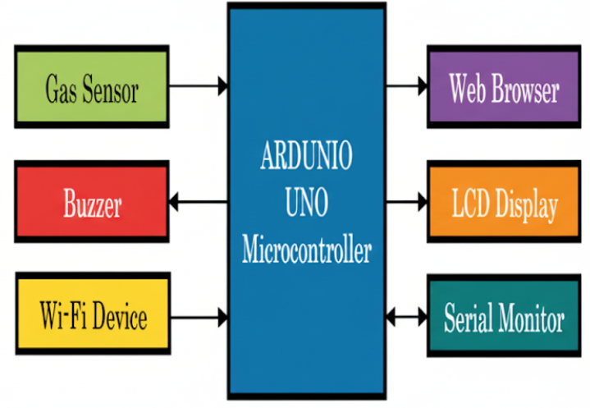
Figure 1: Block Diagram of Proposed work

IV. SETUP OF HARDWARE

Hardware Components

Component | Description & Function
ESP32 Board | The central microcontroller that collects data from sensors, processes it using C++, and transmits via Wi-Fi.
MQ135 Gas Sensor | Detects gases like CO₂, CO, NH₃, and benzene. Used for monitoring air pollutants.
DHT11 Sensor | Measures temperature and humidity, providing environmental calibration data.
I2C LCD (16x2 Display) | Displays real-time readings such as temperature, humidity, and gas concentration directly to the user.
Breadboard | Provides a platform for prototyping without soldering, enabling easy connections.
Jumper Wires | Used for interconnections between ESP32, sensors, and display
USB Cable & Power Source | Powers the ESP32 and connected modules during operation.

V. DISCUSSION

The proposed ESP32-based air quality monitoring system demonstrates several advantages. First, it enables real-time and localized monitoring, which allows faster responses compared to conventional fixed stations. By preprocessing data on the device before transmission, bandwidth and cloud storage costs are reduced, making the system suitable even for large-scale deployments. Another strength is affordability—since sensors and microcontrollers are low-cost, the network can be expanded easily to cover wider areas.
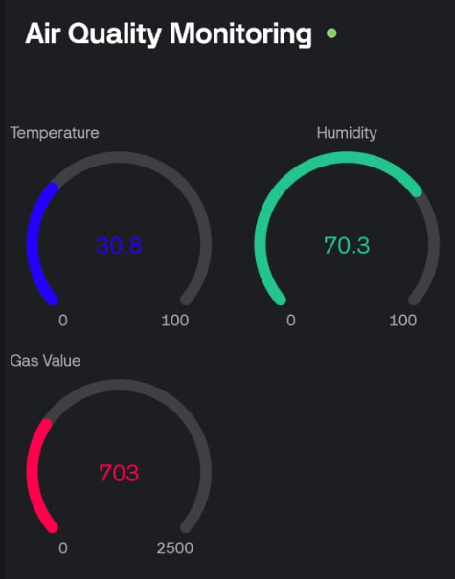
However, challenges remain. Low-cost sensors may show drift and require frequent calibration to maintain accuracy. Environmental factors such as humidity and temperature also affect sensor performance, and while compensation algorithms help, they cannot fully replace periodic recalibration. In addition, long-term maintenance, including filter replacement and firmware updates, is necessary to ensure reliability.
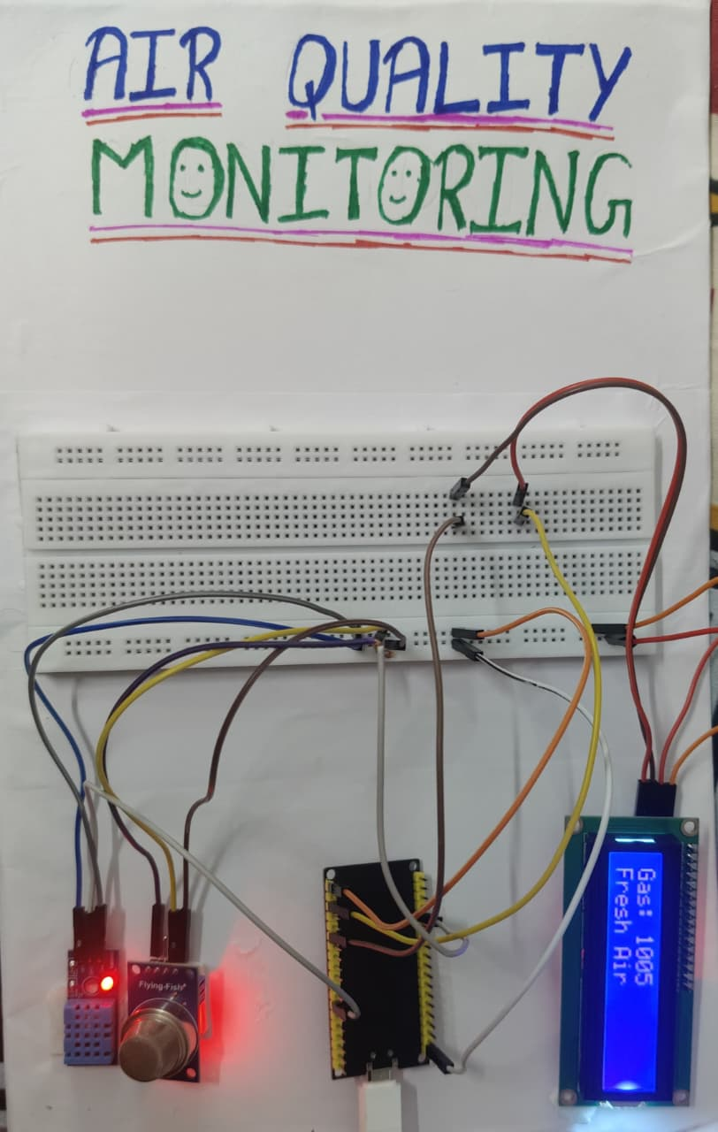
Despite these limitations, IoT-based monitoring holds great promise for smart cities. It can provide community-level alerts during high pollution events, generate heatmaps for urban planning, and supply valuable datasets for public health studies. With improvements in calibration techniques and integration with renewable energy sources, such systems can become a sustainable alternative to traditional monitoring infrastructure.
Figure 2. Real-time working model of proposed work
VI. CONCLUSION AND RESULT
This study demonstrates that IoT-based air quality monitoring using ESP32 and low-cost sensors is an effective, affordable, and scalable solution. The system successfully measures key environmental parameters such as AQI, temperature, and humidity, while providing real-time alerts through cloud integration. On September 28, 2025, the system generated a real-time "pollution_alert" notification (see Figure 4) designating the air quality as "Bad Air," confirming the usefulness of this alerting mechanism. The system's design and potential for raising community awareness are validated by this seamless end-to-end operation, which includes sensor measurement, cloud processing, and user notification.
Compared to traditional monitoring stations, the approach is cost-efficient, community-friendly, and capable of generating localized insights for public health and smart city planning.
Figure 3. Results of Air Quality Monitoring

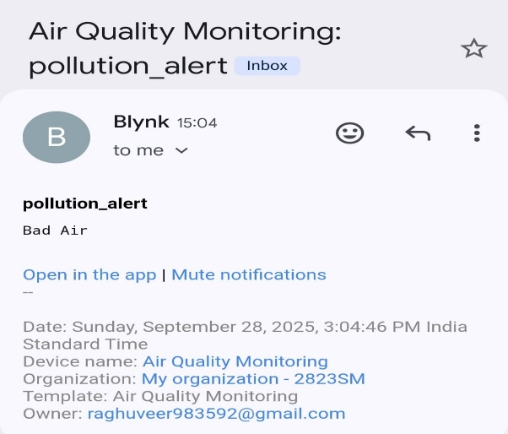
Figure 4: A real-world "Bad Air" alert notification generated by the system, demonstrating the successful cloud-to-user alert mechanism.
VII. FUTURE WORK
- Additional Pollutants: Expand monitoring to gases like NO₂ and O₃ for comprehensive environmental analysis.
- On-Device Intelligence: Apply TinyML models for detecting pollution sources and sensor faults.
- Energy Efficiency: Use solar-based energy harvesting for sustainable, long-term deployments.
- Policy Integration: Connect validated data with municipal dashboards to support decision-making and public advisories.
- Community Engagement: Involve citizen participation through reporting and awareness platforms.

REFERENCES
1. Kumar, S., Tiwari, P., & Zymbler, M. (2019). Internet of Things as a path for technological advancements: A comprehensive review. Journal of Big Data, 6(1), 111.

2. Wang, C., Yin, L., Zhang, L., Xiang, D., & Gao, R. (2010). Metal oxide-based gas sensors: Factors influencing sensitivity. Sensors, 10(3), 2088–2106.

3. Ashby, M. P. J. (2017). Effectiveness of CCTV cameras as an investigative support tool: An empirical study. European Journal on Criminal Policy and Research, 23(3), 441–459.

4. Khan, M. (2020). Development of a sensor-driven gas leak detection unit. Engineering Proceedings.

5. Varma, A., Prabhakar, S., & Jayavel, K. (2017). IoT-enabled gas leakage detection and alert system. In 2017, IEEE 2nd International Conference on Computing and Communications Technologies (ICCCT) (pp. 327–333). IEEE.
6. Evalina, N., & Azis, H. A. (2020). Design and implementation of LPG leakage detection using ATMega8. IOP Conference Series: Materials Science and Engineering, 821(1), 012020.

7. Choche, M., Yadav, A., Shelke, M., & Tyagi, S. (2021). IoT-based hazardous gas leakage detection with Arduino UNO. In Proceedings of the International Conference on Innovative Computing & Communication.

8. Sathyaprabha, S., Abdulrahim, M., & Aarthi, K. (2013). Multilevel alerting system for LPG leakage monitoring. Semantic Scholar.

9. Ilie, A. M. C., & Vaccaro, C. (2017). Smart detection of natural gas leakages through IoT. In 2017, IEEE International Geoscience and Remote Sensing Symposium (IGARSS) (pp. 5954–5957). IEEE.
10. Dwibedi, R. K., et al. (2020). IoT-enabled automatic gas detection. In the International Conference on Recent Advancements in Engineering and Management (ICRAEM).

11. Saranu, P. N., Abirami, G., Sivakumar, S., Ramesh, K. M., Arul, U., & Seetha, J. (2018). IoT-based theft detection with PIR sensor. In 2018 4th International Conference on Electrical Energy Systems (pp. 656–660). IEEE.

12. Sahoo, K. C., & Pati, U. C. (2017). PIR-sensor-based intrusion detection over IoT. In
2nd IEEE International Conference on Recent Trends in Electronics, Information & Communication Technology (pp. 1641–1645). IEEE.

13. Mahalakshmi, P., Singhania, R., Shil, D., & Sharmila, A. (2019). GSM-powered home security system. In N. Shetty, L. Patnaik, H. Nagaraj, P. Hamsavath, & N. Nalini (Eds.), Emerging Research in Computing, Information, Communication and Applications (pp. 543–550). Springer.

14. Nobakht, M., Sivaraman, V., & Boreli, R. (2016). OpenFlow-based host intrusion detection for smart homes. In 2016, IEEE 11th International Conference on Availability, Reliability and Security (ARES) (pp. 147–156). IEEE.

15. Malche, T., & Maheshwary, P. (2017). IoT frameworks for home automation and monitoring. In 2017 IEEE International Conference on I-SMAC (IoT in Social, Mobile, Analytics and Cloud) (pp. 65–70). IEEE.

16. Suma, V., Shekar, R. R., & Akshay, K. A. (2019). IoT-assisted LPG gas leakage alert system. In 2019 3rd International Conference on Electronics, Communication and Aerospace Technology (ICECA) (pp. 131–135). IEEE.

17. Alshammari, B. F., & Chughtai, M. T. (2020). IoT-based safety mechanism for LPG leakage detection. Engineering, Technology & Applied Science Research, 10(4), 6142–6146.

18. Berthier, R., & Sanders, W. H. (2011). Specification-driven IDS for smart metering. In 2011, IEEE 17th Pacific Rim International Symposium on Dependable Computing (pp. 184–193). IEEE.

19. Liu, C., Yang, J., Chen, R., Zhang, Y., & Zeng, J. (2011). Immune system-inspired IDS for IoT networks. In 2011 Seventh International Conference on Natural Computation (Vol. 1, pp. 212–216). IEEE.

20. Jun C, Chi C (2014) “Design of complex event-processing IDS in internet of things” 2014 Sixth International Conference on Measuring Technology and Mechatronics Automation, pp. 226–229. IEEE.

